THIS IS THE LOGIN PAGE FOR THE USERS

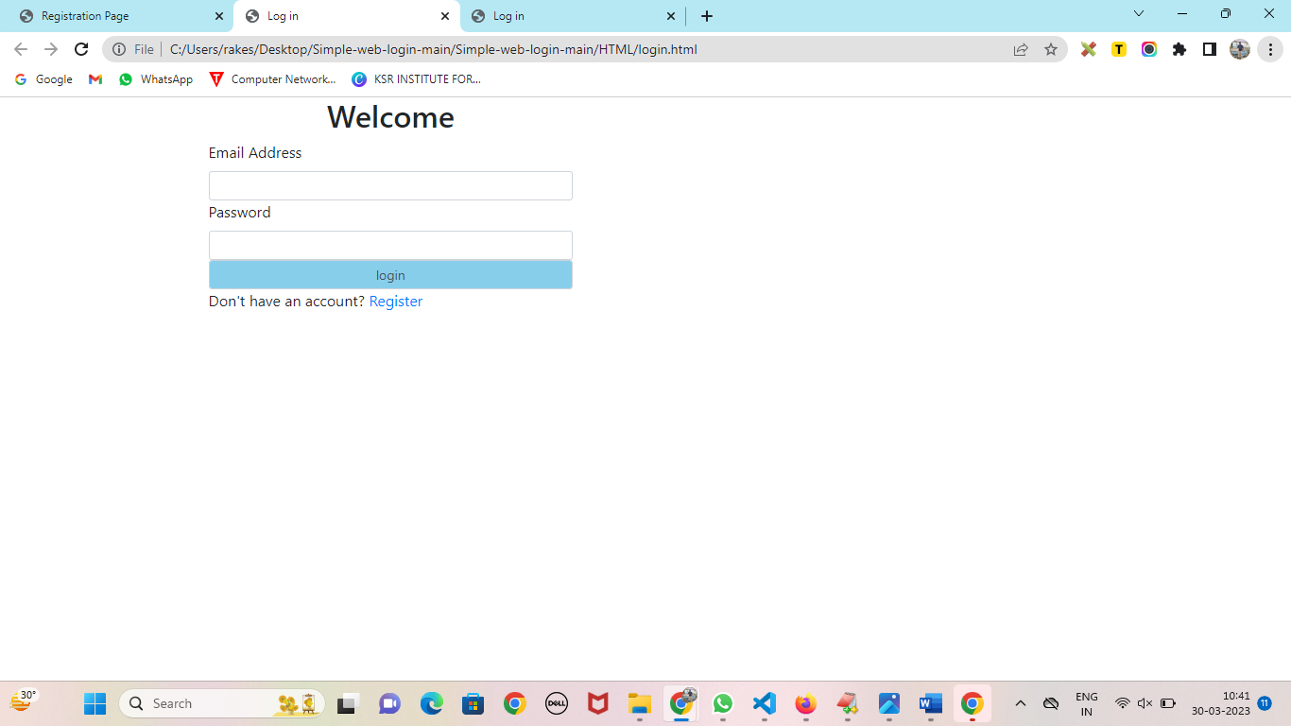

IF YOU ARE A NEW USER MEANS CLICK REGISTER

AFTER CLICKING THE REGISTER LINK THAT WILL REDIRECT TO THE REGISTRATION FORM

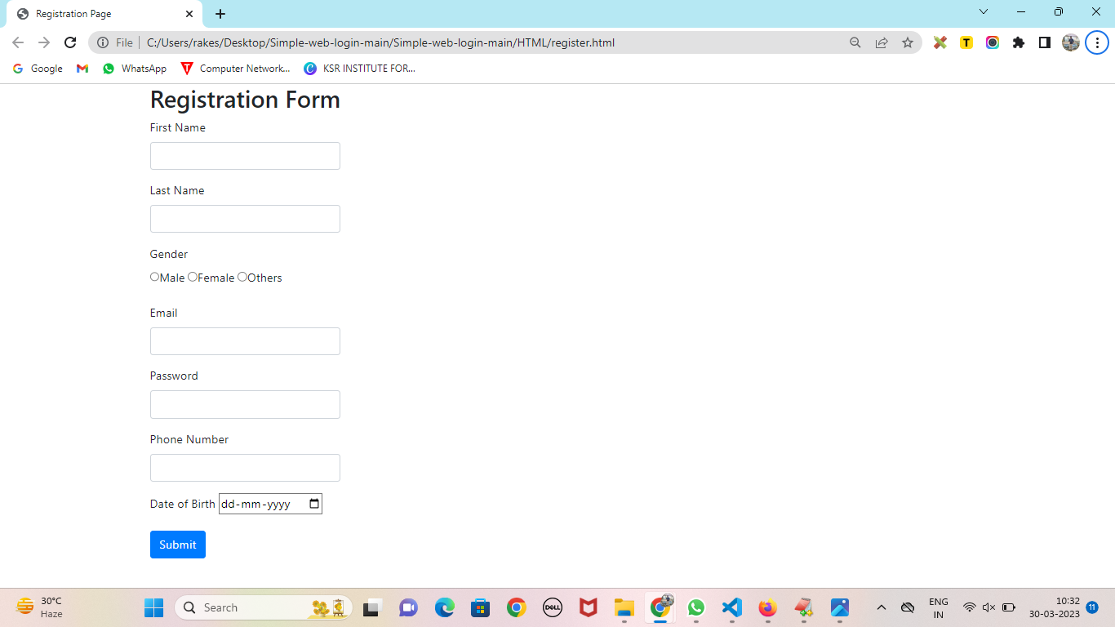

AFTER FILL THE DETAILS CLICK THE SUBMIT BUTTON.THE DETAILS WILL STORE IN MYSQL

BEFORE ADDING THE DETAILS TO THE DATABASE IN MYSQL

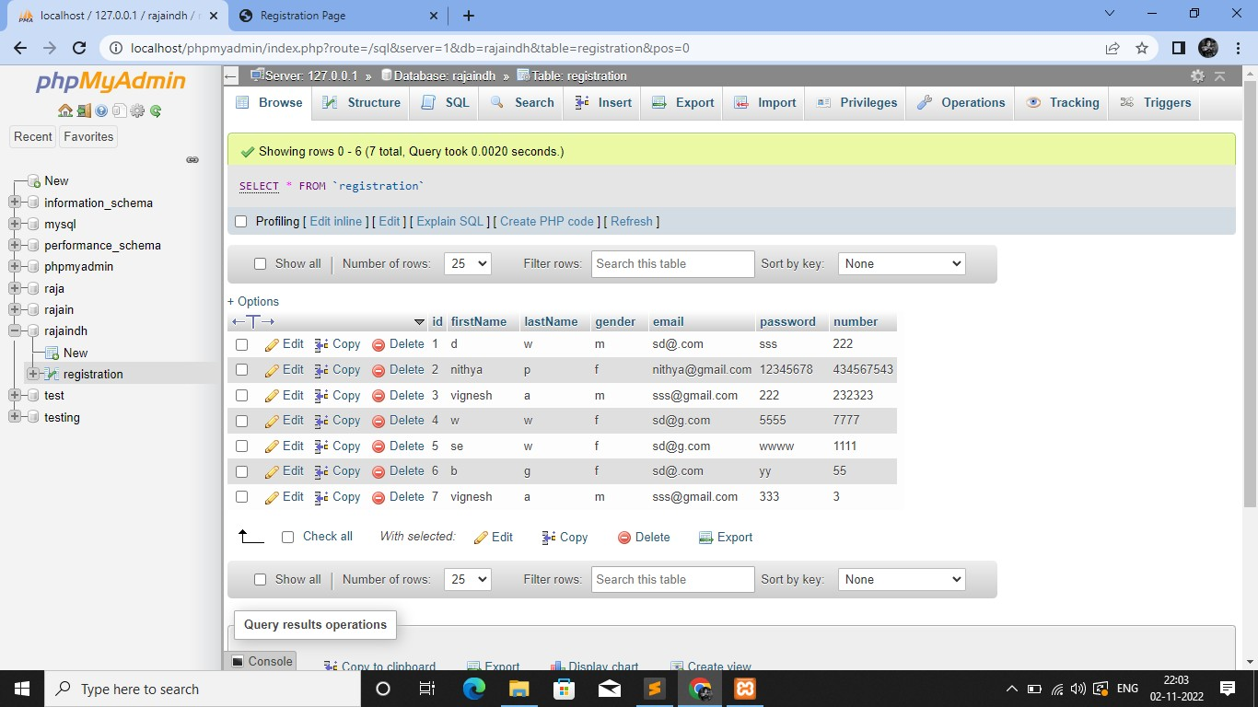

AFTER ADDING THE DETAILS TO THE DATABASE IN MYSQL

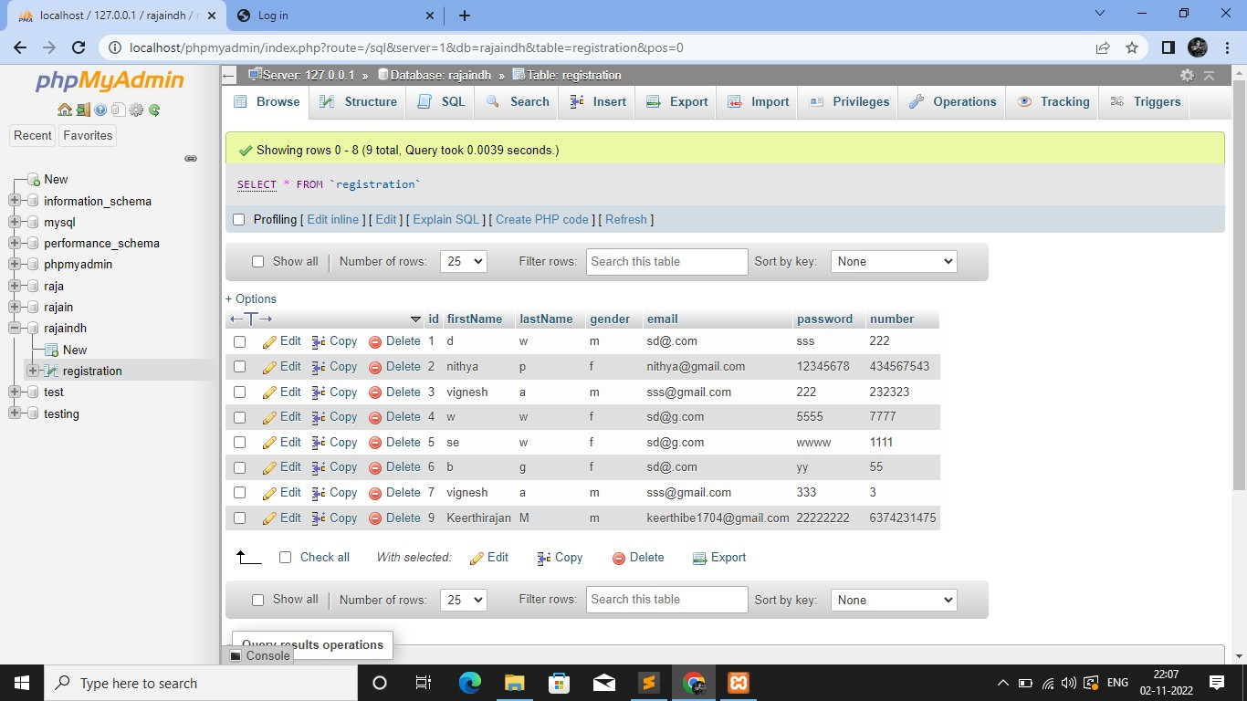

LOGIN WITH VALID DETAILS WILL DIRECTED TO THE WELCOME PAGE

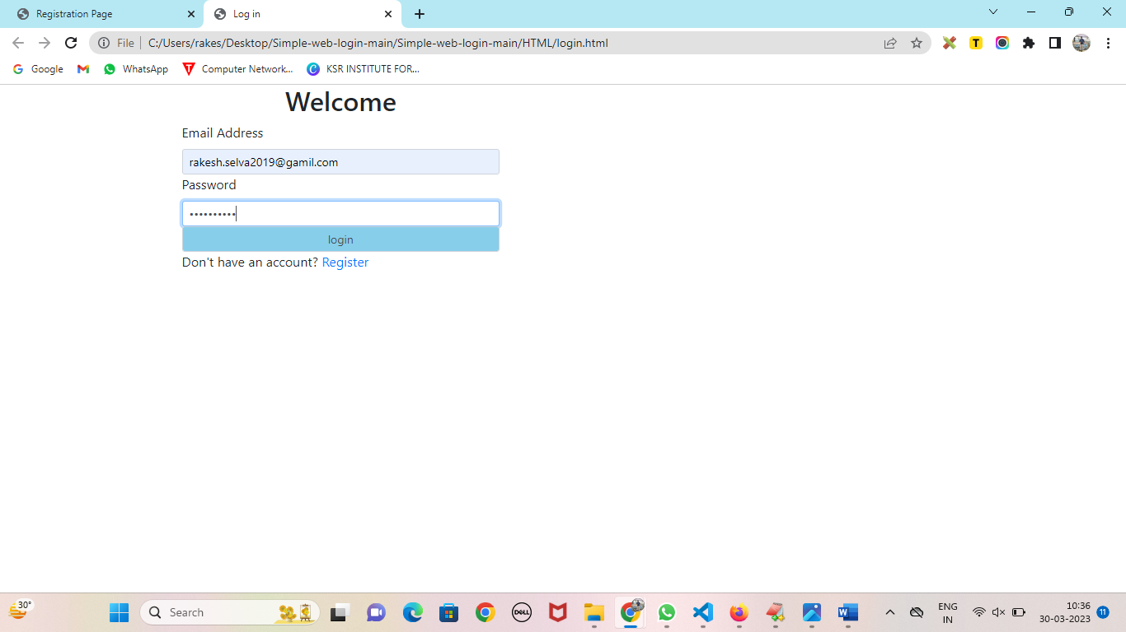

WELCOME PAGE…

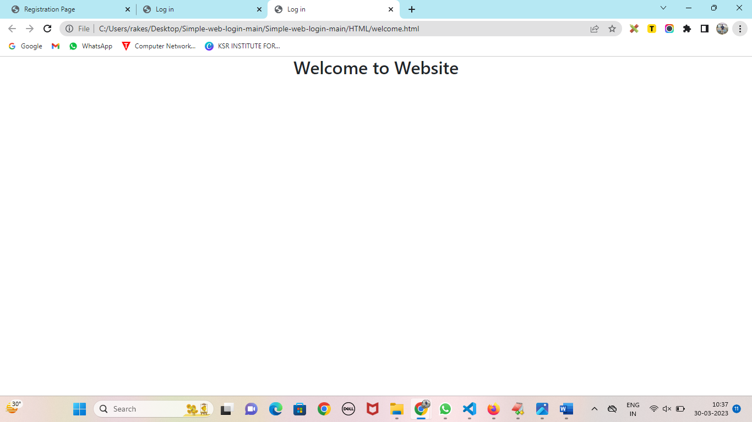

THANK YOU